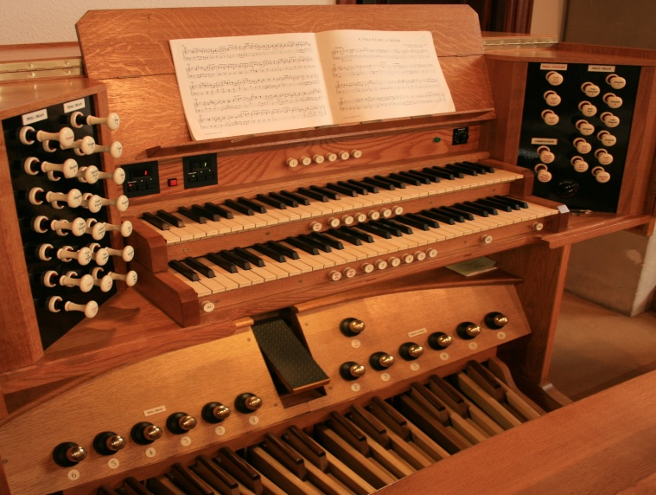

Thursday 10th November 2011
at 7.30 pm

Jeff Williams – Organ
Jeanette Hancock – Alto
Carol Langford - Soprano

Tickets £5
Tickets available on the door or from the Parish office

The Church of the
Holy Angels
Lilliput Road,
Poole
presents
A Charity evening of Organ
and Vocal music, some of which might even be rehearsed!

In aid of

